PENZA STATE UNIVERSITY
INSTITUTE OF TEACHER EDUCATION
DEPARTMENT ‘METHODOLOGY OF SCIENCE, SOCIAL THEORIES AND TECHNOLOGIES’

ROSA LUXEMBURG FOUNDATION IN THE RUSSIAN FEDERATION

INSTITUTE OF GLOBALIZATION AND SOCIAL MOVEMENTS (MOSCOW)

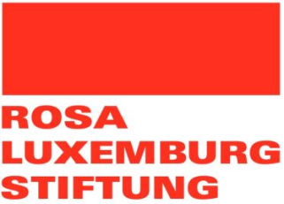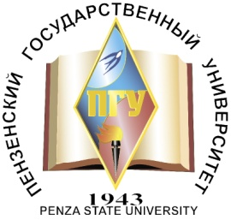

Dear fellow researchers
We invite you to take part in the International Research Conference
“Welfare State in Russia in the Context of World Economic Crisis – Current State, Problems and Perspectives’
(Penza, November 2nd – 3rd, 2016)

Conference goals:

- Overview the current state, dynamics and perspectives in the sphere of social rights and social protection and people’s attitude to these problems, taking Penza region as an example;

- Draw the attention to gender aspects of the welfare state functioning;

- Outline and define major statements that can serve as foundation for the general theory of a welfare state, as well as the mechanisms of its revival and improvement in view of world economic and political situation.

Conference Organizers:

- Rosa Luxemburg Foundation (Germany) in the Russian Federation;
- Penza State University (Penza, Russia);
- Institute of Globalization and Social Movements (Moscow, Russia).

Conference participants will attend plenary sessions, round tables and workshops, formed on the basis of participants’ applications. The conference will concentrate on the following range of problems and issues:

- Philosophical basis of a welfare state.
- Welfare state as a resource of economic development.
- Evolution of the idea of a welfare state from its inception till present day.
- Factors of emergence and development of a welfare state practice.
- Welfare state models: world experience, comparative efficiency and problems of realization.
- Reasons and perspectives of overcoming the crisis of a welfare state.
- Problems of developing the welfare state in present-day Russia.

The conference will also witness the presentation of the research ‘Role of social rights and social protection in the process of Russian families realizing their life strategies’

Applications for participation in a conference with a report are accepted till October 24th, 2016. The application should contain the following details of the participants – surname and names, position and place of work, academic degree, sphere of research interests, report topic and abstract (150 – 300 words). The conference papers will be published.
The articles must be sent until December 15th, 2016. The department ‘Methodology of Science, Social Theories and Technologies’ is responsible for conference matters. Applications are accepted at mnstt@pnzgu.ru; ochkina@inbox.ru.
Contact person: Anna Ochkina, head of the department ‘Methodology of Science, Social Theories and Technologies’ at Penza State University;
Tel.: +78412548622; e-mail: ochkina@inbox.ru

