PENZA STATE UNIVERSITY
Law Faculty
Research and Education Centre for Comparative Legal Policy
Penza Regional Department of Russian Political Science Association
Penza Department of the Association of European Studies

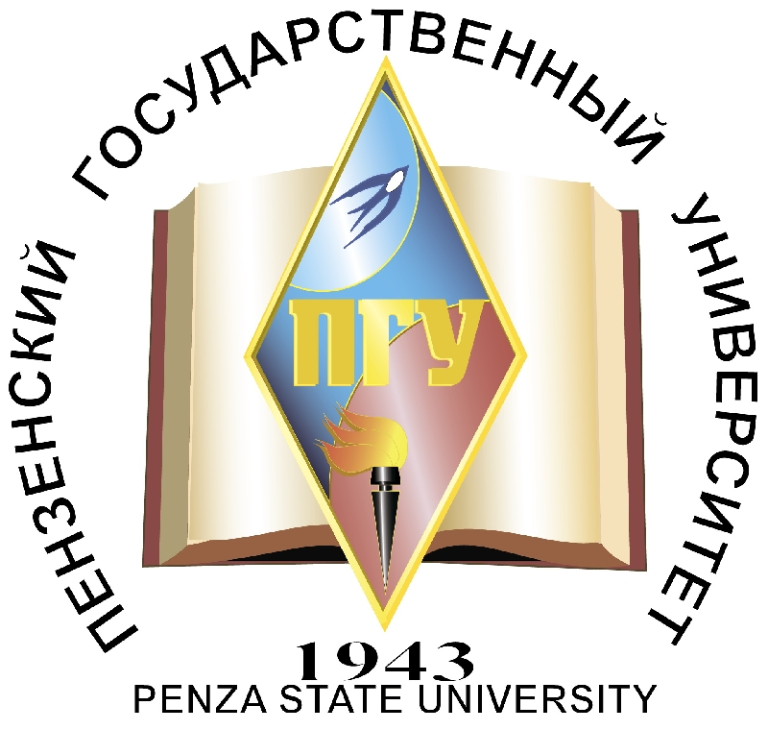

Dear colleagues!

Research and Education Centre for Comparative Legal Policy, Law Faculty of Penza State University, Penza Regional Department of Russian Political Science Association, Penza Department of the Association of European Studies invite you to take part in International Research Conference “Comparative Legal Policy as the most important course of modern legal science”, which takes place in Penza on May, 28th, 2014.
Defending state sovereignty and optimizing legal mechanisms of the Russian society in terms of challenges and conflicts caused by globalization are the strategic goals of comparative legal policy.
Leading Russian experts and colleagues from abroad are going to discuss ways and methods of complex critical analysis of Russian and international state and legal and political experience. Specialists from Germany, Hungary, Belgium, Belarus and the leading Russian universities (Moscow State University of Law, Saratov State University of Law, Ogarev Mordovia State University) take part in the conference.
Conference proceedings are planned to be published.

Contacts: 40 Krasnaya Street, Department of „Theory of State and Law, Political Science“, Penza State University, 440026
e-mail: valeriya_zinovev@mail.ru., tel. (8412)36-80-22

